**The New Tennessee State Library & Archives**

**Expected Construction Completion Date: November, 2019**

…and then we still have to move every document, manuscript, photograph, book, recording, microfilm, and artifact from the current building on 7th to the new building.

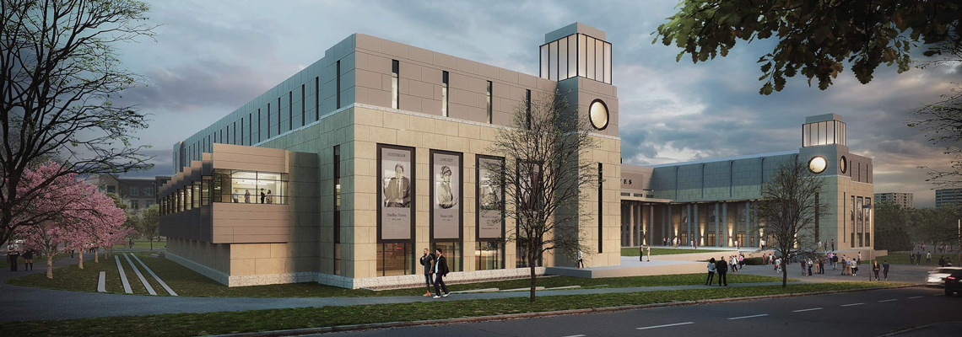

The building will be in a C-shape with a central courtyard opening out onto the Court of Three Stars in the Bicentennial Mall. A 150 car parking garage will be located beneath the building. Only those who have a library card will be able to park there. The first floor will have an exhibits area, open to the public.

Tuck-Hinton, Architects

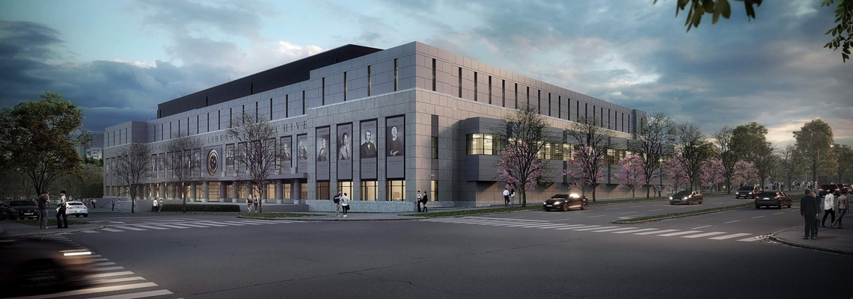

This is the corner of 5th and Jefferson, the north side of the building.

The Library & Archives will include three large meeting rooms seating 100 people each, with airwalls that raise up to make it a single space seating over 300. The building will also include smaller meeting/training rooms.

New building=165,000 sq. ft.

Current building=@100,000 sq. ft.

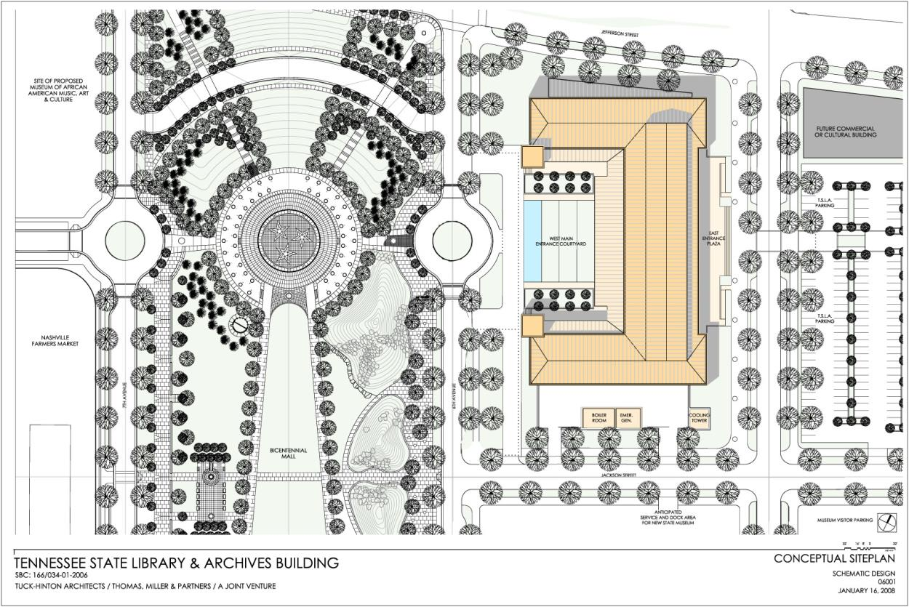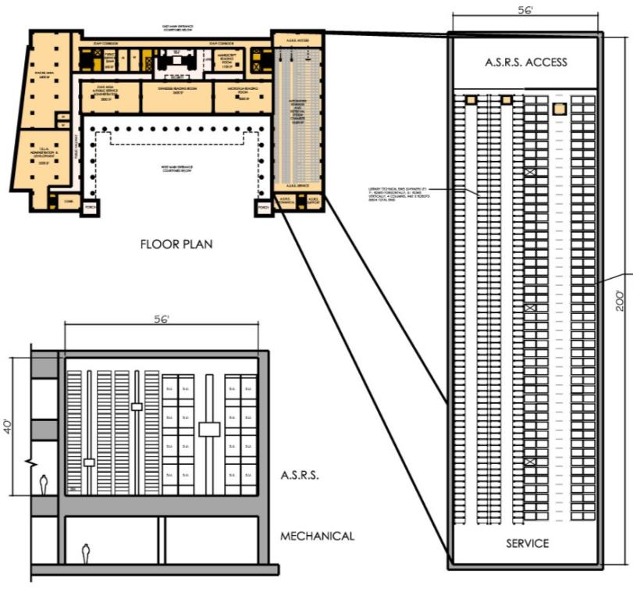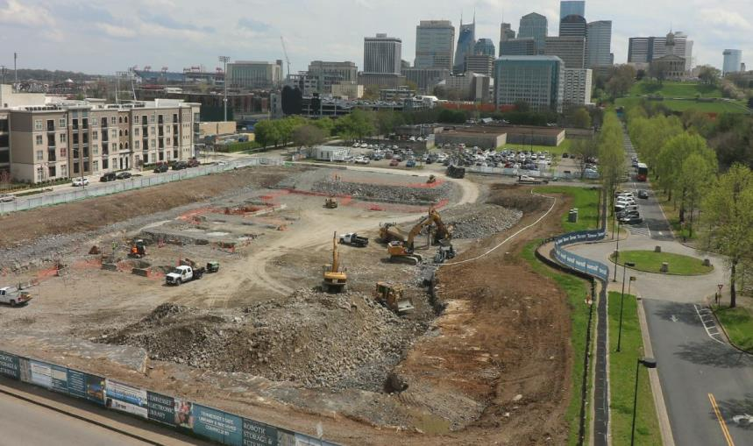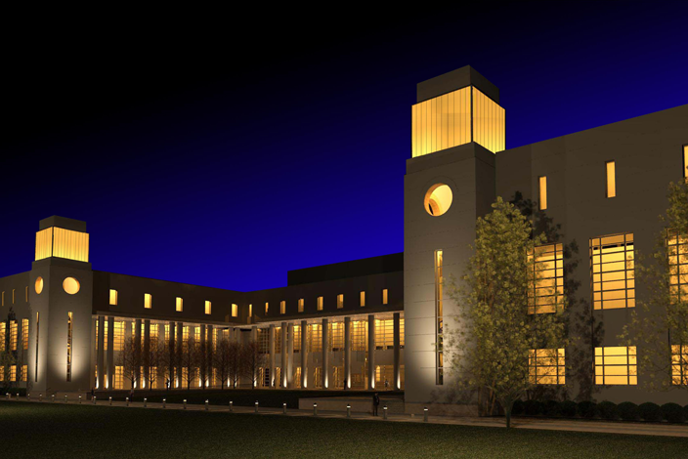

The new Library & Archives will light up the night sky as a beacon to history and Tennessee.

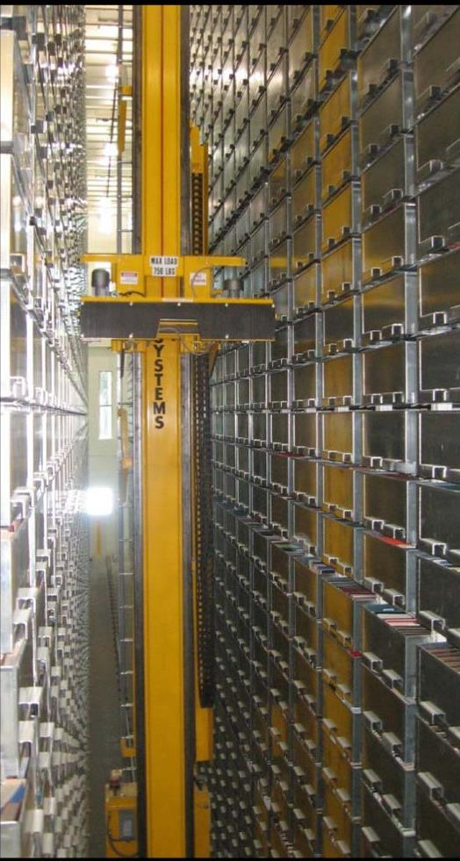

A recent aerial photograph of the new Library & Archives construction site. March, 2018

**The Robotic Retrieval System**